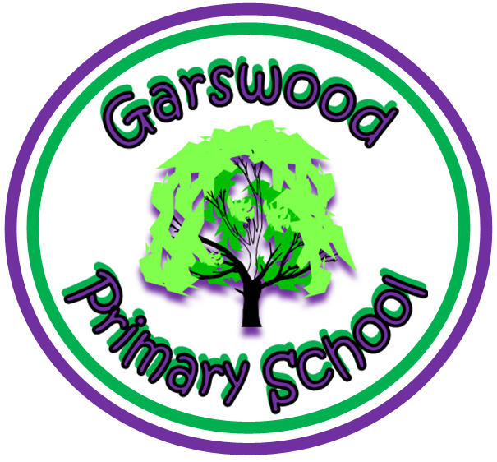
Garswood Primary School.

A Curriculum Policy statement for: Transition

Philosophy:

In order for the children to feel secure, comfortable and successful a gradual and smooth transition from class to class and across Key Stages is critical. The needs of young learners and the philosophy of an active and interesting curriculum for all to access should pervade all classes irrespective of age and stage.

Definition:

In this policy, ‘transition’ describes the movement that takes place from one familiar setting (including the home) to another. It is defined as the process where policy and practice has been adapted to support children in settling into their new learning environment in preparation for future learning and development.

Aims and Objectives:

We want our children to experience a smooth transition throughout their learning, so that the pace and quality of learning are maintained to ensure that children continue to make the very best progress. This policy addresses issues of planning and assessment as well as classroom organisation and teaching styles.

Policy Principles:

• Approaches to teaching and learning are harmonised at the point of transition • Planning is based upon assessment information from the previous class / setting
• Styles of teaching and learning meet the needs of the children and not pre-conceived notions of what is appropriate for the next phase / key stage
• There is a professional regard for the information from the previous setting / phase
• Children are able to enjoy new approaches at transition
• Transition motivates and challenges children
• Staff allocation gives particular attention to the particular needs of the children
Continuity of Teaching and Learning:

At Garswood Primary School, we use the following processes:

Transition from Pre-School to the Foundation Stage:
• Discussions occur between Garswood’s teachers and staff from other settings • Individual tours of the school are offered to all incoming parents and children • Parents of prospective Nursery & Reception children are invited to an induction meeting in June, November and March. Parents receive a ‘Parents’ Pack’ with information about the school
• Home visits are offered to all Nursery and new Reception children
• Prospective Nursery & Reception children visit school on during the term before they start, to become familiar with their new school and setting
• For details on admissions of children please see the school’s Admission Policy
• Children who are moving from Nursery to Reception start full time. Children beginning Reception who are new to the school begin part time in the first 3 days.
• All settings sending children to Garswood complete the “All About Me” transition booklet
• Through observations and the “All About Me” booklet, entry scores are recorded and completed within the first few weeks of entry to the Foundation Unit – this will also highlight the need for any early intervention
• A meeting for parents during the Autumn Term is arranged to explain the teaching of phonics and ‘Letters and Sounds’ and the EYFS curriculum
• The Foundation Unit staff are always available before and after school to chat to parents – they are proactive in talking to parents about issues that may arrive with individual children.

Transition from the Foundation Stage to Year 1:

The Year 1 curriculum builds on and extends the experiences children have had during the Foundation Stage where a kinaesthetic approach to teaching and learning is maintained and built upon to offer creative, hands on method of teaching and learning. The Year 1 classroom aims to reflect a similarity to the Foundation classroom as it exhibits areas of learning available to the children (e.g. funky fingers, art and creativity, outdoor, ICT, reading and quiet areas). Although Year 1 is the first year within which the National Curriculum is followed, we continue to develop the independent learning skills established in the Foundation Unit. Children in Year 1 are encouraged to select resources and activities independently and use decision making skills in their learning, to further consolidate and promote the Characteristics of Effective Learning. Before the children move from the Foundation Stage into KS1 teaching staff meet to discuss the children’s progress. Foundation Stage teachers inform the future teacher of the child’s level of ability, special educational needs and any other information relevant to the well being and development of the child.

Information passed onto Year 1 teachers includes:
• Knowledge of sight words
• Knowledge of letters and sounds (phases)
• Reading ability
• Writing – profile level
• Printed version of each child’s Early Years Foundation Stage Profile (EYFSP) highlighting each of the targets achieved. Information is used to group pupils, adjust / fine-tune the curriculum and set future targets. Links are made between Early Learning Goals (ELG’s) and National Curriculum (as many statements within the Foundation Stage curriculum are similar to the key objectives for numeracy and early criteria for literacy skills)

Transition in subsequent years throughout the school:

Before the children move from onto the next class teaching staff meet to discuss the children’s progress. Teachers inform the future teacher of the child’s level of ability, special educational needs and any other information relevant to the well-being and development of the child.

All children visit new classes and work alongside new teachers on ‘Transition Week’ in the summer term. Throughout the year, there are shared assemblies, buddy reading systems, PE coaching and project based opportunities where children throughout the school mix together to enable them to get to know other staff as well as each other. Teachers meet to discuss individual children’s progress as they move from class to class. ‘Early intervention’ policy for SEN children Targets in reading, writing and numeracy. Gold writing books move with children to provide evidence of previous years’ progress.
Transfer of records: For example, IEPs, Assessment & attendance data, Profile Folder (including child’s annual report to parents)

Children Joining from Year 1 to Year 6:

• Individual tours offered to all incoming parents and children, time for the child to stay with the current class is also offered to help get them acquainted with their new surroundings
• Parents receive a ‘Parents’ Pack’ with information about the school • New children assessed quickly by class teacher and / or SENCO
• A ‘buddy’ is identified to help the new child to integrate
• Records from previous school are made available to the class teacher and SENCO

Transition from Year 6 to Year 7:

• Teachers from Garswood’s feeder secondary schools visit to provide lessons throughout the year (E.g. French)
• The Year 7 tutors visit Year 6 to meet the children and discuss their thoughts and concerns ahead of transfer – a ‘Pen Picture’ of each child is provided by the Year 6 class teacher.
• A formal meeting takes place between the Year 6 teacher and the Year 7 tutor of the receiving secondary school
• The Year 6 teacher liaises with the Year 7 teacher from the receiving school to create a profile of assessment data and transition needs for each child
• Identified children (e.g. SEN) receive additional support before and after transition by attending taster days.
• The transfer of records to the receiving secondary school takes place
• Year 6 children attend their prospective secondary school for a Transition Day during the summer term of Year 6 and during Year 5 they visit feeder schools.

Equality, Diversity and Inclusion:

Children and parents are actively involved in all transition processes that take place while at Garswood and their perceptions about transition are explored and valued. Measures are taken to ensure that pupils with learning or access difficulties experience a similar ease of transfer as other pupils.

Garswood Primary School Transition Policy:

At Garswood School, we aim to ensure that no member of the school community experiences harassment, less favourable treatment or discrimination within the learning environment because of their age; any disability they may have; their ethnicity, colour or national origin; their gender; their religion or beliefs. We value the diversity of individuals within our school and do not discriminate against anyone because of ‘differences’. We believe that all our children matter and we value their families too. We give our children every opportunity to achieve their best by taking account of our children’s range of life experiences when devising and implementing school policies and procedures.

This policy will be regularly reviewed by the Governing Body and updated annually.

Reviewed by Suzanne Bagshaw, May 2023

