Garswood

Primary School

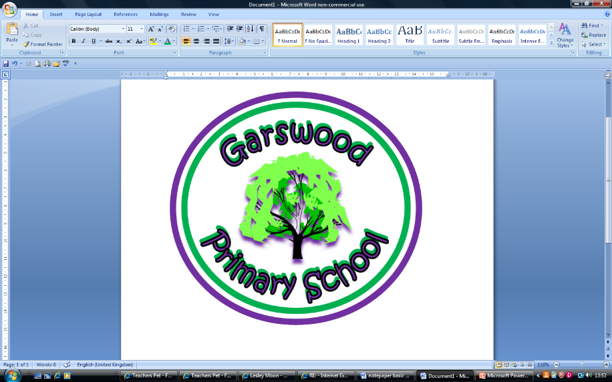

A Curriculum Policy Statement for:

**Early Years Foundation Stage**

EYFS at GarswoodAt Garswood Primary we aim for children to leave our school with great memories; to have developed into happy, caring, well rounded individuals.  We want children to feel empowered to change the world for the better.  We aim for children to be inspired to take from life all the positives and achieve the very best. We want their dreams to come true.

Children begin their Garswood Journey in the Early Years Foundation Stage (EYFS) which applies to children from birth to the end of the Reception year. At Garswood Primary School, children may join the Nursery class in the term that they turn 3. The Foundation unit consists of 2 year old provision, Nursery 1, Nursery 2 and Reception. In partnership with parents and carers we enable the children to begin the process of becoming active learners for life.

The EYFS Framework states:

‘Every child deserves the best possible start in life and the support that enables them to fulfil their potential. Children develop quickly in the early years and a child’s experiences between birth and age five have a major impact on their future life chances. A secure, safe and happy childhood is important in its own right. Good parenting and high-quality early learning together provide the foundation children need to make the most of their abilities and talents as they grow up.

The Early Years Foundation Stage (EYFS) sets the standards that all early years providers must meet to ensure that children learn and develop well and are kept healthy and safe. It promotes teaching and learning to ensure children’s ‘school readiness’ and gives children the broad range of knowledge and skills that provide the right foundation for good future progress through school and life.

The EYFS seeks to provide:

• quality and consistency in all early years settings, so that every child makes good progress and no child gets left behind

• a secure foundation through planning for the learning and development of each individual child, and assessing and reviewing what they have learned regularly

• partnership working between practitioners and with parents and/or carers

• equality of opportunity and anti-discriminatory practice, ensuring that every child is included and supported

The EYFS specifies requirements for learning and development and for safeguarding children and promoting their welfare. The learning and development requirements cover:

• the areas of learning and development which must shape activities and experiences (educational programmes) for children in all early years settings

• the early learning goals that providers must help children work towards (the knowledge, skills and understanding children should have at the end of the academic year in which they turn five)

• assessment arrangements for measuring progress (and requirements for reporting to parents and/or carers)

**Welfare**

It is important to us that all children in the school are ‘safe’. We aim to educate children on boundaries, rules and limits and to help them understand why they exist. We provide children with choices to help them develop this important life skill. Children should be allowed to take risks, but need to be taught how to recognise and avoid hazards. We aim to protect the physical and psychological well-being of all children.

“Children learn best when they are healthy, safe and secure, when their individual needs are met and when they have positive relationships with the adults caring for them.”

At Garswood Primary School we understand that we are legally required to comply with certain welfare requirements as stated in the Statutory Framework for Early Years Foundation Stage. We understand that we are required to:

* promote the welfare and safeguarding of children.
* promote good health, preventing the spread of infection and taking appropriate action when children are ill.
* manage behaviour effectively in a manner appropriate for the children’s stage of development and individual needs.
* ensure all adults who look after the children or who have unsupervised access to them are suitable to do so.
* Ensure that the premises, furniture and equipment is safe and suitable for purpose
* Ensure that every child receives enjoyable and challenging learning and development experiences tailored to meet their needs.
* Maintain records, policies and procedures required for safe efficient management of the setting and to meet the needs of the children.

The EYFS is based upon four principles:

• every child is a **unique child**, who is constantly learning and can be resilient, capable, confident and self-assured;

• children learn to be strong and independent through **positive relationships**;

• children learn and develop well in **enabling environments**, in which their experiences respond to their individual needs and there is a strong partnership between practitioners and parents and/or carers;

• children **develop and learn** in different ways and at different rates.

**A Unique Child**

At Garswood Primary School we recognise that every child is a competent learner who can be resilient, capable, confident and self-assured. We know that children develop in individual ways and at varying rates. Children’s attitudes and dispositions to learning are influenced by their school and home environments and we begin to build links with the families. We observe how each child learns to gain an understanding of the characteristics they develop to become effective learners. We use questioning, praise and encouragement to develop a positive attitude to learning and high self-esteem.

***Inclusion***

All children and their families are valued within our school. We value the diversity of individuals within the school and do not discriminate because of differences. All children at Garswood Primary School are treated fairly regardless of race, religion or stage of learning. We do not group children based on notions of fixed ability. We teach the children that practice and effort lead to learning and improvement. In the early years the children begin to learn to take responsibility for their learning and begin to understand the concept of challenge.

We give our children every opportunity to achieve their best by taking account of our children’s range of life experiences when planning for their learning. Planning for children with additional needs is in line with the Special Educational Needs & Disability policy.

In the EYFS we have realistic and challenging expectations and meet the needs of all our children through:

*planning opportunities that build upon and extend children’s knowledge, experience and interests and develop their self-esteem and confidence through a creative curriculum and learning environment

*using a wide range of teaching strategies based on children’s learning needs

*providing a wide range of opportunities and environments to motivate and support children and to help them to learn effectively

*providing a safe and supportive learning environment in which each child’s contribution is valued

*monitoring children’s progress and taking action to provide support as necessary

It is vital that all children in the school are safe.

**Positive Relationships**

At Garswood Primary School we recognise that children learn to be confident and independent through the development of secure relationships. We develop caring, respectful, professional relationships with the children and their families.

***Parents as Partners***

We recognise the important role parents play in educating the children. We do this by:

*talking to parents about their child and offering a home visit before their child starts our school;

*inviting the children to spend time with their teacher in the classroom before starting at school

*inviting all parents to an induction meeting during the term before their child starts school

*encouraging parents to contribute to observations using Evidence Me

*inviting parents to SHARE sessions to learn how they learn

*encouraging parents to talk to the child’s teacher if there are any concerns.

*There is a formal meeting for parents three times a year at which the teacher and the parent discuss the child’s progress in private with the teacher. Parents receive a report on their child’s attainment and progress at the end of each school year;

*arranging a range of activities throughout the year that encourage collaboration between child, school and parents: SHARE, celebration assemblies, school visits;

Staff develop good relationships with all children, interacting positively with them and taking time to listen to them.

We have good links with the local feeder nurseries, and we visit settings that children attend outside of Garswood. The EYFS team meet with together to discuss new intake children.

**Enabling Environments**

At Garswood Primary School we recognise that the environment plays a key role in supporting and extending the children’s development. The role of both the indoor and outdoor environment in learning/organisation of learning provides opportunities for both independent child-initiated activities and focused activities. We aim to create an attractive and stimulating learning environment where children feel confident and secure and challenged. The children have daily access to an indoor and outdoor environment that is set up in discrete areas of learning with planned continuous provision. Effective learning builds and extends upon prior learning and following children’s interest. Effective planning is informed by observations of the children to ensure we follow their current interests and experiences. These observations are recorded in ‘magic moments’ and learning stories. Play based learning is paramount and children direct their own learning from carefully planned opportunities provided by staff. Staff will enhance play and extend as needed to further individual learning.

***Observation, Assessment and Planning***

Each area of learning and development is implemented through planned, purposeful play and through a mix of adult-led and child-initiated activity. Play is used as an essential part children’s development, building their confidence as they learn to explore, to think about problems, and relate to others. Children learn by leading their own play, and by taking part in play which is guided by adults. There is an on-going judgement to be made by practitioners about the balance between activities led by children, and activities led or guided by adults. Practitioners must respond to each child’s emerging needs and interests, guiding their development through warm, positive interaction.

Planning and guided children’s activities will reflect on the different ways that children learn and reflect these in their practice. At Garswood we support children in using the three characteristics of effective teaching and learning.

We plan firsthand experiences and provide opportunities for challenges appropriate to the development of the children.

In the EYFS assessment of attainment and progress is based on observation, discussion, questioning and evidence of children’s independent learning. Valuable evidence of children’s learning is obtained through observation of independent and targeted learning. These observations are undertaken by teachers and teaching assistants.

**Learning and Development**

At Garswood Primary School we recognise that children learn and develop in different ways and at different rates. We value all areas of learning and development equally and understand that they are interconnected. The children have time and freedom to become deeply involved in the activities and their learning.

***Areas of Learning***

The EYFS is made up of six areas of learning:

PRIME AREAS

• Personal, Social and Emotional Development

• Physical Development

• Communication & Language

SPECIFIC AREAS

• Literacy

• Mathematics

• Understanding the World

• Expressive Arts and Design

Through careful assessments and observations, including information provided by parents and other settings, children’s development levels are assessed. The balance will shift towards a more equal focus on all areas of learning as children grow in confidence and ability within the three prime areas. However, if a child’s progress in any prime area gives cause for concern, staff will discuss this with the child’s parents and/or carers and agree how to support the child. This may also include a discussion with the Special Educational Needs leader or the Family Support Worker.

13

14

15

16

17

18

19

20

21

22

23

24

25

26

27

28

29

30

31

32

33

34

35

36

37

38

39

40

41

42

43

Play

‘Children’s play reflects their wide ranging and varied interests and preoccupations. In their play children learn at their highest level. Play with peers is important for children’s development.’ Through play, our children explore and develop learning experiences, which help them make sense of the world. They practice and build up ideas, learn how to control themselves and understand the need for rules. They have the opportunity to think creatively alongside other children as well as on their own. They communicate with others as they investigate and solve problems.

Active learning - children will have time and space to concentrate and keep on trying if they encounter difficulties and enjoy their achievements.

‘Children learn best through physical and mental challenges. Active learning involves other people, objects, ideas and events that engage and involve children for sustained periods.’

Active learning occurs when children are motivated and interested. Children need some independence and control over their learning. As children develop their confidence, they learn to make decisions. It provides children with a sense of satisfaction as they take ownership of their learning.

Creating and thinking critically - we encourage and support children to have and develop their own ideas, make links between ideas, and develop strategies for doing things.

“When children have opportunities to play with ideas in different situations and with a variety of resources, they discover connections and come to new and better understandings and ways of doing things. Adult support in this process enhances their ability to think critically and ask questions.”

Children should be given the opportunity to be creative through all areas of learning. Adults can support children’s thinking and help them make connections by showing interest, offering encouragement, clarifying ideas and asking open ended questions. Children can access resources and move around the classroom freely and purposefully to extend their learning.

Children’s play reflects their wide ranging and varied interests and preoccupations. In their play, children can be inquisitive, creative, questioning and experimental and will learn at their highest level. Playing with their peers is important for children’s development.

Through play our children explore and develop learning experiences, which help them make sense of the world. The adults model play and play sensitively with the children fitting in with their plans and ideas. The children are encouraged to try new activities and judge risks for themselves. We talk to them about how we get better at things through effort and practice and that we can all learn when things go wrong. They practice and build up ideas learning how to control themselves and understand the need for rules. They have the opportunity to think creatively alongside other children as well as on their own.

Equal Opportunities

All members of the school are treated as individuals. We aim to meet the needs of all, taking account of gender, ability, ethnicity, culture, religion, language, sexual orientation, age, special educational needs, disability, and social circumstances. All staff are aware of the need for the curriculum to reflect cultural diversity and the need to prepare pupils for life in a diverse and multi-faith society.

Health and Safety

At Garswood, there are clear procedures for assessing risk which includes procedures for keeping children safe during outings and for any aspects of the environment or provision that may require a further risk assessment.

In line with the Early Years Framework , at Garswood we undertake;

* A whole school medicines policy ensuring that there are systems in place to ensure that medicines and the systems for obtaining information about a child’s needs for medication are kept up to date. Medicines will not be administered unless they have been prescribed by a doctor, dentist, nurse or pharmacist. Medicines (prescription) are only administered to a child where written permission for that particular medicine has been obtained from the child’s parent and/or carer.
* Fresh drinking water is available at all times
* Children’s’ dietary needs are recorded and acted upon when required
* The classroom has a snack and sink area that can provide healthy snacks and drinks.
* A first aid box is accessible at all times and a record of accidents and injuries is kept EYS teaching assistants are paediatric first aid trained.

Transition

**From Pre-school**

During the term prior to a child’s entry into the Nursery or Reception year, the following procedures have been put into place to ensure successful transition

* Parents are invited to an induction meeting to ensure they know about school procedures and allocation of classes and any concerns they may want to express.
* The children are invited to visit their class for stay and play sessions.
* Members of staff from Garswood make visits to feeder settings. The number of visits will depend on the child’s needs and how much information gathering is required in order to support the child’s transition.

**From Reception Class to Key Stage 1**

During the final term in Reception, the EYFS Profile is completed for each child. The Profile provides parents and carers, staff and teachers with a well-rounded picture of a child’s knowledge, understanding and abilities, their progress against expected levels, and their readiness for Year 1. The Profile includes on-going observation, all relevant records held by the setting, discussions with parents and carers, and any other adults whom the teacher, parent or carer judges can offer a useful contribution.

Each child’s level of development is assessed against the early learning goals. The profile indicates whether children are meeting expected levels of development, or not yet reaching expected levels (‘emerging’). Year 1 teachers are given a copy of the Profile report together with a short commentary on each child’s skills and abilities in relation to the three key characteristics of effective learning. This informs the dialogue between Reception and Year 1 teachers about each child’s stage of development and learning needs and assists with the planning of activities in Year 1.

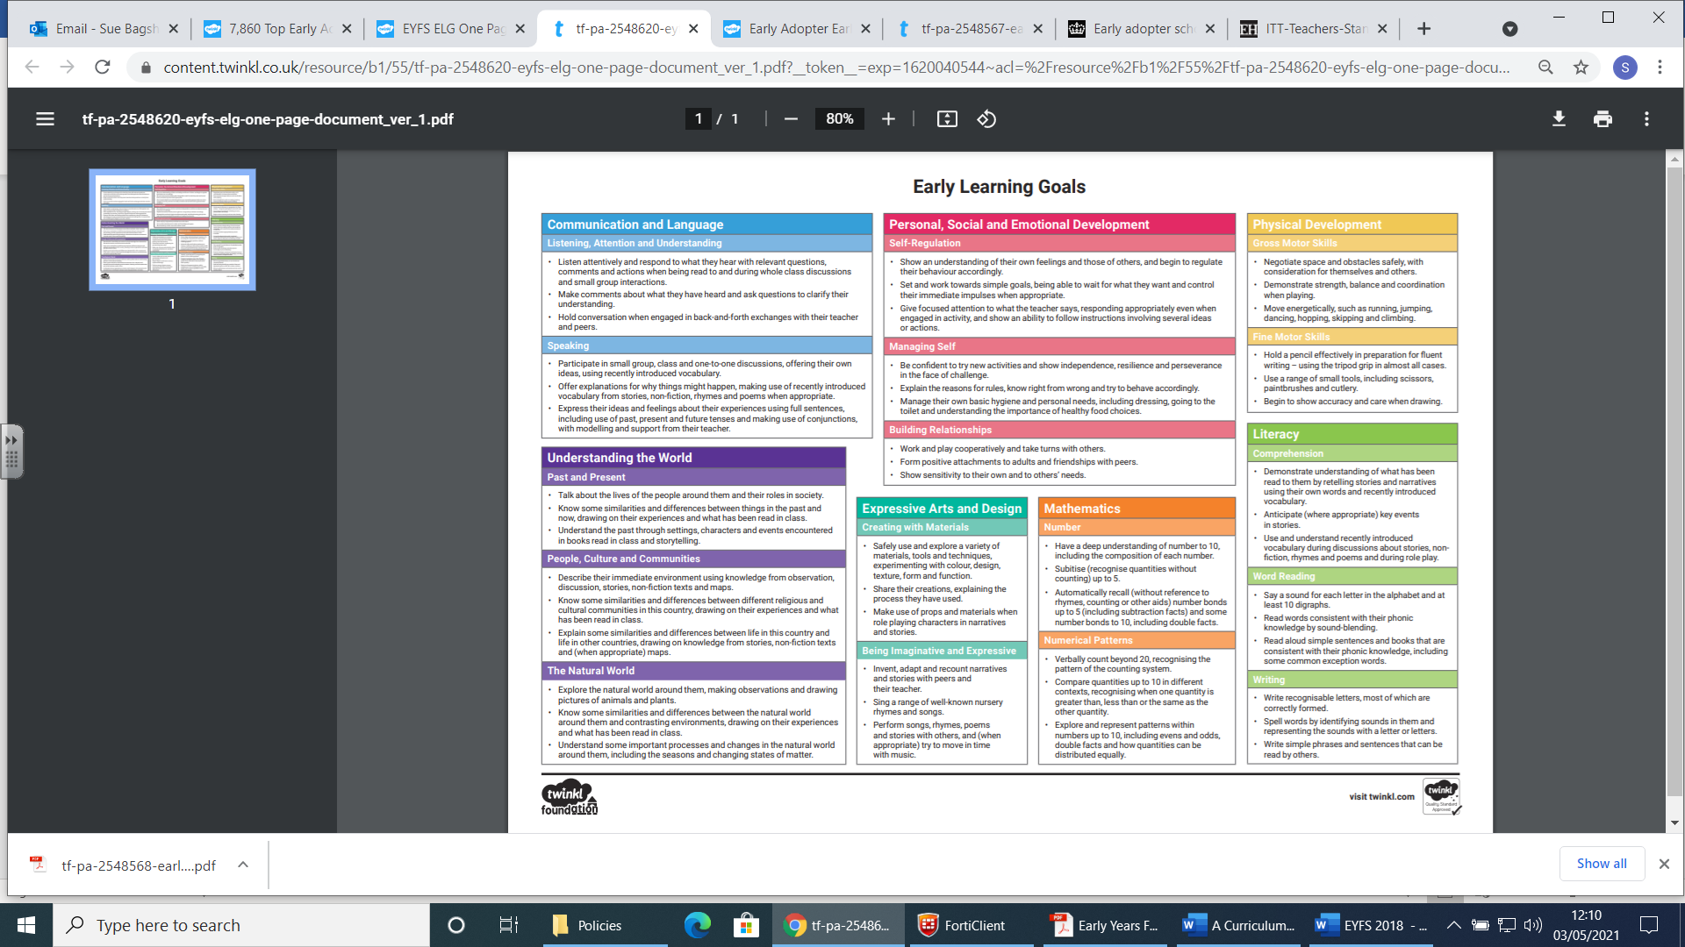

Characteristics of Effective Teaching and Learning:

• playing and exploring - children investigate and experience things, and ‘have a go’

• active learning - children concentrate and keep on trying if they encounter difficulties, and enjoy achievements

• creating and thinking critically - children have and develop their own ideas, make links between ideas, and develop strategies for doing things.

Policy written and adapted by Sue Bagshaw April 24