Garswood Primary School
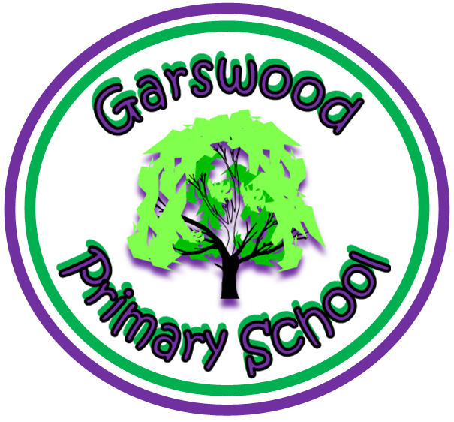
A Policy Statement for: Food Safety in Nursery
Policy on food, allergies and cultural restrictions
Food safety policy
Garswood Nursery is committed to ensuring that safe and healthy practices around the storage, preparation and service of food are maintained throughout the setting.
Cleaning of Food Preparation Areas
The setting has set high standards of personal hygiene for all members of staff involved in the handling and preparation of food. Any person showing signs of ill health will not be permitted to handle food.
Fridges are cleaned thoroughly on a weekly basis and all items in the fridge are date checked, all food past their use by or best before date are correctly disposed of.
- Shelves and drawers are removed and cleaned with warm soapy water.
- The inside walls are cleaned from top to bottom with anti-bacterial cleaner.
- The seals around the fridge are cleaned to ensure no spillages or stains.
- Freezers are defrosted (on non-frost-free) and cleaned once a month following the same procedure.
All food preparation surfaces are wiped clean after use with anti-bacterial cleaner and disposable cloths.
All chopping boards are cleaned after use with warm soapy water, anti-bacterial cleaner and then thoroughly rinsed.
The EYFS lead will ensure that kitchen staff follow the appropriate controls are in place to prevent cross contamination and that these controls are documented accordingly.
Healthy Eating
At Garswood Nursery, we believe that nutritious food and drink are essential for children’s wellbeing.
During meal and snack times, we will always encourage children to gain an understanding of how food and water is an essential part of growing big and strong. Our aim is to meet the dietary and cultural requirements to promote children’s healthy growth and development. All Children will always have access to fresh drinking water during their day and during mealtimes.
We will ensure that all meals and snacks are nutritious, healthy, and balanced. Children’s medical and personal dietary requirements are always known and respected (Parents/carers are required to provide details when their child is enrolled into the nursery). Multicultural diet is always offered, to make sure those children from all backgrounds encounter familiar tastes and that all children have the opportunity also to try new food. Dietary rules of religious groups, vegetarians/vegans are known and met in an appropriate way, making sure that they are always respected and valued within the setting.
When preparing food, staff (kitchen or general) will observe current legislation regarding food hygiene and training by:
- Washing hands with anti-bacterial soap and hot water before and after handling food, using the toilet, or changing nappies.
- Using clean, disposable cloths
- Ensuring the use of the correct colour coded chopping boards
- Not being involved in food preparation if they are unwell.
- Wearing correct sterile clothing- hair net, apron, closed toe shoes and disposable gloves etc.
- Holding a current Food Hygiene certificate.
- Making sure all fruit and vegetables are washed before being served.
- Any cuts, spots or sores on the hands and arms must be covered completely with a waterproof dressing.
- Fingernails should be kept short and clean, food handlers, including children should not wear nail varnish as this may contaminate food.

Allergies/Restrictions
The nursery caters for children’s specific dietary needs that may include allergies or food intolerances (confirmed by a doctor/dietician in writing) , or because of religious, cultural, or ethical reasons.
Staff are made aware of children’s specialist requirements through individual care plans and other information provided by parents.
If food restrictions are at the preference of parents and not a medical need, parents are required to provide “free from” alternatives in an unopened packet to the nursery.
To help us manage the risks associated with food allergies or intolerance the nursery has the following in place.
- Pre-entry information from parents
- Induction information from staff
- Food allergen risk assessment
- Excellent food hygiene practises
- Written procedures for children with food related conditions.
Temperature control
It is the policy of Garswood Nursery to ensure that all foods are stored according to safe food handling practises and at the correct temperature in order to prevent the growth and multiplication of food poisoning organisms, to reduce the rate of food spoilage and to ensure that food quality is maintained.
Fridge temperatures are checked and recorded daily to ensure the correct temperature is being upheld.

Things to remember when supervising children
- Children should always sit up and on a chair while eating and be supervised.
- 2 year olds must have a member of staff sitting opposite whilst feeding.
- Do not hurry the child when eating—allow plenty of time for meals.
- Avoid round, firm foods and large chunks (whole grapes, apple) (see chart below)
- Cylindrical foods should be to cut lengthwise. (see chart below)
- Avoid stringy foods like string beans and celery.
- Food pieces should be no larger than one-half inch in any direction. If in doubt, cut food into smaller pieces.
- Jacket Potatoes – The Potatoes should be taken out of the skin once cooked.
- All cooked vegetables served with meals should be well cooked. Vegetables such as corn cobs should be avoided and changed to free flow options such as kernels.
- Any bread items such as Hot Sandwiches and Pizza Bases, should be lightly cooked to avoid and overly firm and crispy edges. They can be covered whilst cooking to avoid and direct dry heat contact
- Sausages should be in half sliced Lengthways
- Breaded/Battered Foods should not be overcooked and over crispy.
- Chips and or Roast potatoes should be lightly cooked to avoid any overly crispy edges. Mash or New Potatoes can be used as an alternative where required. (Follow procedure for Changes in Menu)
- Fresh Fruit and salad should be prepared in the style of Sticks/Batons with any skin or rind removed.

Information from St Helens Council:
Nursery Meals – Food Preparation and serving process

Our service may provide meals to Nursery aged children from age 2+. It is not the Catering Services responsibility during mealtimes to observe children eating, However we will support mealtimes for such children with the way meals are prepared and served.

The below information must be followed for such occasions.

- All standard Food Safety policies and procedures still apply.
- Children with Dietary Requirements are still required to go through the service’s Special diets Procedure.

- The Primary menu and portion size guidance should be the default menu. However, Food should be cooked and prepared in such a way that the age of the child is taken into consideration. See the below examples of certain food that occur on our Primary menu in how adjustments should be made

- Jacket Potatoes – The Potatoes should be taken out of the skin once cooked.
- All cooked vegetables served with meals should be well cooked. Vegetables such as corn cobs should be avoided and changed to free flow options such as kernels.
- Any bread items such as Hot Sandwiches and Pizza Bases, should be lightly cooked to avoid and overly firm and crispy edges. They can be covered whilst cooking to avoid and direct dry heat contact
- Sausages should be in half sliced Lengthways
- Breaded/Battered Foods should not be overcooked and over crispy.
- Chips and or Roast potatoes should be lightly cooked to avoid any overly crispy edges. Mash or New Potatoes can be used as an alternative where required. (Follow procedure for Changes in Menu)
- Fresh Fruit and salad should be prepared in the style of Sticks/Batons with any skin or rind removed.

by Sue Bagshaw
January 2025

