02.02.2023 Ancient Egypt
What can you discover about Egypt?

What was the river called that Ancient Egypt was near? ________________________________________________________________________________

Can you find these objects in the museum and tell me about them?
Tick the box when you locate them and write what the object is.
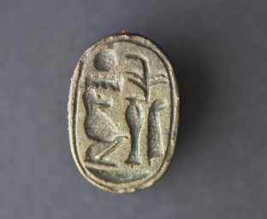
_____________________________________________________________________________________________________________________________________________________________________________________________________________________________________________________________________________________________________________________________________________________________________________________________

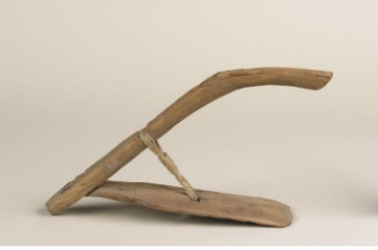
_____________________________________________________________________________________________________________________________________________________________________________________________________________________________________________________________________________________________________________________________________________________________________________________________
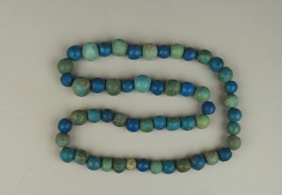

_____________________________________________________________________________________________________________________________________________________________________________________________________________________________________________________________________________________________________________________________________________________________________________________________
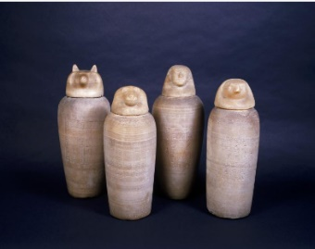
_____________________________________________________________________________________________________________________________________________________________________________________________________________________________________________________________________________________________________________________________________________________________________________________________

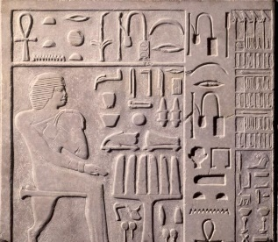

_____________________________________________________________________________________________________________________________________________________________________________________________________________________________________________________________________________________________________________________________________________________________________________________________

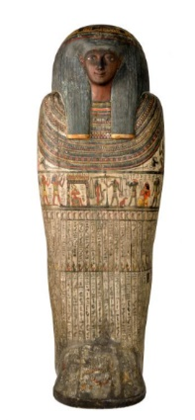

____________________________________________________________________________________________________________________________________________________________________________________________________________________________________________________________________________________________________________________________________________________________________________________________________________________________________________________________________________________________________________________________

What other information have you found about the Ancient Egyptians?
___________________________________________________________________________________________________________________________________________________________________________________________________________________________________________________________________________________________________________________________________________________________________________________________________________________________________________________________________________________________________________________________________________________________________________________________________________________________________________________________

