[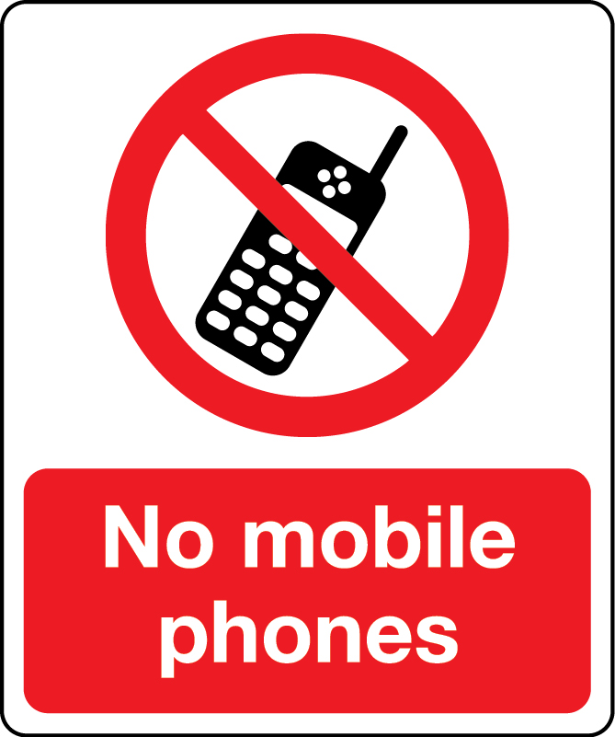](https://www.stocksigns.co.uk/wp-content/uploads/2016/05/05194.jpg)

The Garswood Internet Safety Team has decided that for the safety of staff and pupils, mobile phones should be switched off or on silent while in Garswood Primary School. Please refrain from checking your phone whilst on school grounds to avoid any misunderstandings. This is for the safety of the pupils, staff and visitors. Thank you for your cooperation.